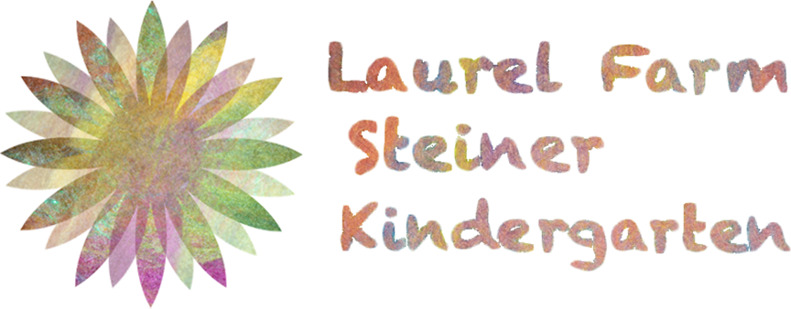

FOOD AND HYGIENE POLICY

Prepared with reference to; Food Policy in Schools A Strategic Policy Framework for Governing Bodies
Food handling, preparation and serving in the classroom – Food Standards agency
Active, growing children require plenty of wholesome food and regular meals. At The Laurel Farm kindergarten, we believe that we can offer something that will satisfy everyone. We work with our suppliers to make as much use as appropriate of organic, natural food. We ensure that our suppliers are committed to providing best quality and value, with the highest standards of accredited health and safety.
A hot, homemade vegetarian lunch is available in the kindergarten our meals are prepared using fresh ingredients.
Nursery children get lunch, morning snack of fruit and rice cakes /oat cakes and afternoon tea, this can be any of the following home-made bread, spreads, fruit.
DRINKING WATER
Drinking water is widely available throughout the nursery and children are encouraged to drink few time per day.
ALLERGIES AND SPECIAL DIETARY REQUIREMENTS
Parents of children who have allergies to any food product, or who have special dietary requirements, are asked to make this clear in the medical questionnaire which they complete when their child enters the kindergarten. They should inform the kindergarten at once if their son or daughter subsequently develops an intolerance of any food.

HEALTH AND SAFETY
We recognise that compliance with health and safety is fundamental to any catering operation. We attach the highest importance to ensuring that we are compliant with EU and UK legislation at all times. Overall responsibility for the catering function (including health and safety) lies with the Head Teacher.
All of our food staff have Food and Hygiene certificates. Our kitchen complies with all relevant Health and Safety requirements and we have a Hygiene rating of 5.
MANAGEMENT OF FOOD SAFETY
In managing food safety, Laurel Farm Kindergarten will:
Staff Training
- Require all staff that assist with food preparation to possess a basic food hygiene certificate.
- Ensure that all appropriate staff have clearly allocated responsibilities, which they understand
- Maintain records of training.
Staff Uniforms and Personal Hygiene
- Ensure that all staff wear their appropriate protective clothing, at all times when they are in areas where food is prepared and served.
- Ensure compliance with the hand-washing or hand cleansing regime at all times.
Food Preparation, Serving and Consumption
- Inspect all areas where food is prepared, served and consumed for cleanliness and hygiene at both the start and end of every meal.
- Monitor the dining room, counters, for dirty plates, cutlery etc, together with the containers/bins for waste food throughout the service of every meal.
- Ensure that all spills are dealt with promptly and safely. If necessary, cordon off areas of the floor that have become slippery.
2
Purchasing and Checking Stock
- Ensure that food supplies are only purchased from a reliable and authorised source.
- Check all that all supplies used are in date and undamaged.
- Check that stock is properly stored as soon as it arrives.
Equipment
- Report all equipment failure to the kindergarten manager as soon as it is discovered.
- Ensure all chopping boards, surfaces are not worn or broken
- Do not use chipped crockery, always ensure all items are clean
First Aid
• Ensure that the kitchen first aid box is kept fully stocked in accordance with professional recommendations.
Signage
• Display the appropriate First Aid sign
Waste Disposal
• Arrange the hygienic disposal of waste in accordance with recommended practice.
This policy will be reviewed (and if necessary revised with the approval of the Laurel Farm Kindergarten Team) on an annual basis.
Issue date
This policy takes effect from March 20147
Review date
This policy will be reviewed and revised by the school manager on an annual basis.
Updated September 2017 by Dominika Baran
Net update September 2018

