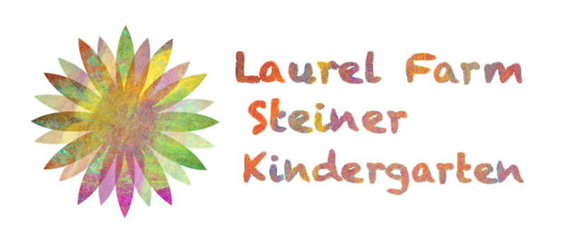

Early Years Foundation Stage (EYFS)
Assessment and Reporting Policy

Updated: Kelly Harries (Chair of Trustees) and Dominika Baran (Advisory Teacher) January 2019

To be reviewed: September 2019

Early Years Foundation Stage Assessment Policy

Assessment plays an important part in helping parents, carers and practitioners to recognize children’s progress, understand their needs, and to plan activities and support their child as much as possible. The staff respond to their own day-to-day observations about children’s progress and observations that parents and carers share.

As each child enters the Early Years Foundation Stage (EYFS) we use our professional judgement to assess the age band children are working ‘within’ across the EYFS 17 areas of learning. Within 4 weeks of the child starting kindergarten they complete a ‘baseline’ assessment and the results are recorded on the Early Years Tracking Tool.

Formative Assessment
Ongoing assessment (also known as formative assessment) is an integral part of the learning and development progress.
Provision is made for observations and assessments through experience and play based learning. Assessment does not entail prolonged breaks from interaction with the children nor require excessive paperwork by the teacher. Progress is recorded by observing and assessing children daily and recording in a variety of ways, e.g. hand written observations and notes, photographs highlighting developmental steps.

ASSESSMENT CYCLE

Baseline – Within 4 weeks of entering the Kindergarten

Progress - Assessment of progress will be made during Assessment Week on a twice a year. These assessments / learning diaries will be shared with parents.

Parents may request a progress meeting at any time during the Kindergarten term by communicating with the teacher.

Summative data
2.5-3 years old– (with emphasis on the seven areas of learning) and Summer – with judgements (made against the EYFS criteria for each area of learning) characteristics of learning and next steps.

4-6 years old –with emphasis on the seven areas of learning and next steps. Twice a year children are assessed against the EYFS Profile Early Learning Goals, stating whether they are EMERGING, EXPECTING or EXCEEDING. The EYFS profile is shared with parents as part of their End of the year report.

The transfer record is used when a child moves to another setting/school
PARENTS

Parent’s contributions are highly valued.

Parents are included in the following ways:
Home visits /Getting to know you form
Parent contribution forms “Special moments “
Communication Books
Parent Notice Boards – planning documents
Newsletters
Parent/teacher meetings upon request
1:1 meetings with teachers
Parents’ Evenings (1 per term)
Informal chats at drop off and pick up

End of year reports are handed to parents during final meetings Summer term.

LOCAL AUTHORITY

The EYFS profile results are sent to the Banes County Council every summer (upon request). The local authority is under duty to return this data to the relevant Government department.

This policy will be reviewed before the start of each academic year and will evolve to incorporate the views of all staff concerned.

