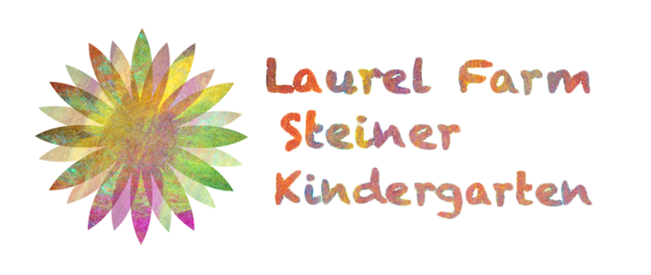

Online Safety Policy
Including Photography, Video, and Mobile Phone Use

Created by: Kelly Harries October 2019
Update due: October 2020

- Purpose

Laurel Farm Kindergarten is aware that the use of digital technology has vastly increased and that this poses a new safeguarding concern for our children due to the potential misuse of photography, videos, computers and mobile phones.

Laurel Farm Kindergarten has a commitment to keeping children safe and this policy operates at all times under the umbrella of our Safeguarding and Child Protection Policy.

This policy aims to:
- be clear on the responsibilities of all staff, including volunteers and Trustees, when using cameras, mobile phones and laptops within the setting.
- safeguard children’s welfare in relation to the above and minimize the risk of harm.
- how Laurel Farm Kindergarten provides its children with as safe an internet environment as possible and how it teaches them to be aware of and respond responsibly to possible risks.
- Fulfil legal duties in relation to personal data and other areas: Data Protection Act 2018.

- Principles

Laurel Farm Kindergarten recognizes that children are exposed to internet use, mobile phones and computers at home and in their environment, and that unmediated internet access brings with it the possibility of placing children in embarrassing, inappropriate and even dangerous situations. Therefore we have a responsibility to teach e-safety to our children, even though they are not exposed to it within the setting.

Laurel Farm Kindergarten recognizes that the use of video or photography may have been used with children that have been previously abused and therefore they may feel threatened by its use in the setting. Staff must remain sensitive to any children who appear uncomfortable and should recognize the potential for misinterpretation.
Laurel Farm Kindergarten recognizes that internet safety in the setting depends on staff, parents, carers and visitors taking responsibility for their personal use of the internet and other communication technologies such as mobile phones. It is our responsibility to have clear guidelines for everyone to follow.

- Managing Risk

3.1 Kindergarten Use of Photos and Videos

- Kindergarten staff will only use the Kindergarten owned mobile phone to take photographs and videos of the children. The staff are NEVER permitted to use their personal phone for taking photos or videos of the children within the setting. The staff are NEVER permitted to have on their person or to use any mobile phone or camera in the changing areas or toilets. The Kindergarten mobile must have a password which only the staff members know and it must be securely locked away after use. The Kindergarten mobile phone must NEVER left unattended or in reach of children.
- On enrolment parents are asked to complete a photo consent form where they can give or deny consent for photos of their children to be used within the setting (in learning journals) and online (website, facebook, Instagram, newspaper). Parents are assured that their child’s name is NEVER printed online, unless they give specific consent to the person publishing it, such as in a newspaper article.
- In order to minimize the risk of unsolicited attention from internet users the Kindergarten will undergo certain measures when sharing photos online. There are: children must be in suitable clothes to maintain modesty, where consent has not been given these children’s faces will NEVER appear in the photo (only an unidentifiable body part such as a hand), children will only be included in the photo if necessary and most of the images shared will be of their children’s work and not themselves.
- It is not common for the Kindergarten to take videos of the children so if this occasion were to arise, at a festival for example, then separate parental consent will be obtained for that event only.

3.2 Staff / Parents / Visitors Mobile Phone Use

- All staff and volunteers working directly with children must not use their personal mobile phone during Kindergarten hours (Tues 9.30am – 2pm, Weds/Thurs 9.30am – 4.30pm). The only time they are permitted to use their mobile phone is in the case of an emergency. If this occurs they must not use their mobile phone in the playroom or in sight and hearing distance of the children (they can use it in the kitchen).
- All staff and volunteers must store their phones outside the playroom, in their bags and on a peg high enough so the children cannot reach it. Their phone must be set to “silent”.
- All staff and volunteers must never use their personal phones to contact parents. They must only use the Kindergarten phone provided. This is to safeguard the staff and to maintain a professional relationship with them.
- Any visitors to the Kindergarten must follow the procedures outlined above.
- Parents are also asked to follow these procedures and are asked to avoid mobile phone use at drop off and pick up. If the parents need to make a phone call they are asked to do this outside of the Kindergarten in the car park.

3.3 Kindergarten E-Safety Actions

- Laurel Farm Kindergarten adheres to the Early Years Foundation Stage, however, due to it’s Steiner ethos it has been granted an exemption from “Understanding The World: Technology” by the Secretary of State. This means that children are not introduced to digital technology of any kind within the Kindergarten Years (2.5-6 years) and have no access to computers, phones, laptops, cameras etc. We do not use digital educational games or programs or have any access to the internet. Within the Kindergarten setting the children are at no risk from harm in relation to technology.
- Laurel Farm Kindergarten accepts that although we don’t provide access to these technologies within the setting, we still have a responsibility to teach e-safety to our children. We recognize that children may be exposed to neighbours or friends computers or phones, or their parents phones at home and therefore we have to take action to safeguard them.
- For children under the age of 5, which is the vast majority of our attendees, the responsibility lies with the parents. Laurel Farm Kindergarten would not teach e-safety directly to children under 5, but instead will teach it to parents via discussion at parents evening and regular email bulletins. Parents need to be made aware of the risks of channels such as YouTube where children’s cartoons, such as Peppa Pig and Thomas & Friends, have voice overs added which have adult content and are highly inappropriate for children. Also the need to have passwords and parental access on tablets, and to have their phone locked at all times.
- For children over the age of 5 the Kindergarten Teacher will teach e-safety directly to children. As we don’t have access to computers, tablets or mobile phones these cannot be used. Instead the Teacher will use stories or puppet shows about feeling unsafe and what to do if someone makes them feel unsafe i.e. tell an adult. Through these stories and conversations we are encouraging a culture of feeling safe. The teacher will have direct conversations with children over 5 about e-safety and how to stay safe when visiting friends, family and neighbours such as don’t use someone’s phone unless the parent has said its ok.
- For teaching children and parents about online safety and how to safeguard themselves we will use the NSPCC Online Safety Website as our resource https://www.nspcc.org.uk/preventing-abuse/keeping-children-safe/online-safety/
AND
The Internet Matters Website
https://www.internetmatters.org/resources/esafety-leaflets-resources/

- Consent

- The Data Protection Act 2018 affects our use of photography. This is because an image of a child is personal data for the purpose of the Act and it is a requirement that consent is obtained from the parent of a child under the age of 18 years before any photographs or video recordings are taken. It is also important to ascertain the views of the child and to observe whether the use of photography is making them uncomfortable. Where a child is Look After we must check consent with the Social Worker on the parents behalf.
- Once consent is gained the photos / videos will be used throughout the year for individual learning journals and publicity, i.e. facebook, Instagram, leaflets, newpapers etc.
- If parents have an objection to this they reserve the right to not sign the consent form.
- Parents reserve the right to withdraw consent at any stage and are required to put this in writing.
- You can view a copy of our photo consent form at the end of this policy.

- Communication

Laurel Farm Kindergarten understands that children and staff need to be safeguarded when using emails and social networking sites, for instance from potential online hackers and from false allegations. Therefore have these procedures in place:

- Children will not have access to e-mails.
- Staff using e-mails will use a Kindergarten e-mail address. This address must not be used for personal e-mails.
- When staff need to discuss the children over email with parents they will say “your child”, rather than naming the child.
- When staff need to discuss the children over email amongst themselves they will only use the child’s initials.
- Online chat rooms and social networking sites such as Facebook or Instagram will not be used within Kindergarten hours. These will only be used by the Kindergarten Teacher and Trustees when they is posting updates of the children’s work and play, or upcoming events, and this will only be outside of Kindergarten hours.
- Staff will not discuss individual children or their setting on facebook, twitter or any other social networking site.

- Storing Images and Videos

This section relates to our Data Protection Policy and our Remote Working Policy. These policies should also be read alongside the Online Safety Policy.

- Digital images will be stored in a separate file on the Kindergarten Teacher’s computer, which is accessed by Staff and Trustees only. These images must be stored in accordance with data protection laws e.g. password protected laptop and laptop locked away in the premises.
- Digital images will be printed out and stored in a paper form in the child’s individual learning journal. When the child leaves the setting their learning journal will be handed to their parents. The digital images of children leaving the setting will be deleted from our computer files, unless the parent has given consent for Laurel Farm Kindergarten to use the images for future publications, i.e. our website.

- Policy Breach

- If it is suspected that a staff mobile phone or technological device may contain unsuitable material, the nature of the material should be documented and the Chair of Trustees and Designated Safeguarding Lead should be informed. The process outlined in the Safeguarding Policy will be followed, including taking advice from external agencies (e.g. police, LADO) as appropriate.
- It is the staff’s responsibility to ensure they understand this policy and if they are found to be in breach of it, i.e. using their personal mobile phone to take photographs, then they will face disciplinary action.

Photo Consent Form

Please complete the information below and return to Laurel Farm Kindergarten.

We would like to ask your permission to use the photographs we may have taken of your children at work or play. These could be used for individual records, online on our website or social media web pages such as Facebook / Twitter / Instagram, in brochures, magazines or newspapers and our newsletter. The images will always be checked by one of the teachers first. No child will be named (other than in their learning journal).

Please delete, and sign the form below.

I agree to my child’s photograph being used for their individual learning journal within the Kindergarten.

Yes / No

I agree to my child’s photograph being used on the Kindergarten Website.

Yes / No

I agree to my child’s photograph being used on Facebook and Instagram

Yes / No

I agree to my child’s photograph to be used for publications such as leaflets or newspapers.

Yes / No

Any further specifications? I.e. Not my child face please ...................................................................................................................................

......................................................................................................................................

Signed………………………………………………………………………………………

Full Name…………………………………………………………………………………..

Full Name of child………………………………………………………………………….

Date .............................................................................

